Audiograph code review standards

* Used signed integers where possible to hold data from the lfm server (in case it ever returns a negative number, there is no overflow exception)
* Use variables to hold repeated strings
* Use the following to add multiple subitems with 1 line of code
* All “frm.Open()” statements must be followed by an “frm.Activate()” statement
* Use CInt, CUInt, Csng, etc. instead of CType except where necessary
* Don’t use ByVal unless ByRef is also present
* All operations that require authorization must have an authorization check in case they are ran accidentally with no authorization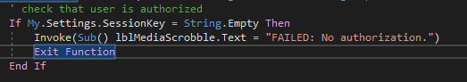
* Use constants when variables don’t need to be changed

RTF box formatting standard:

